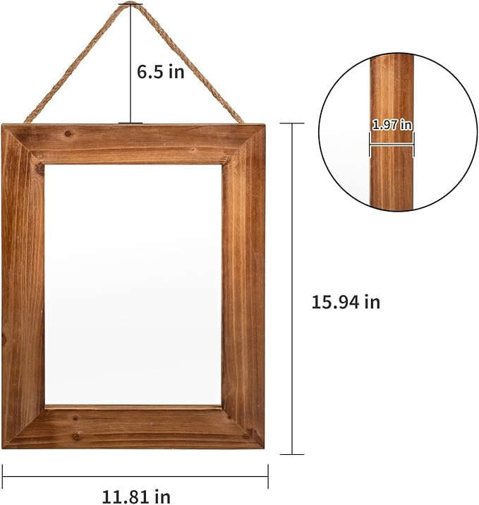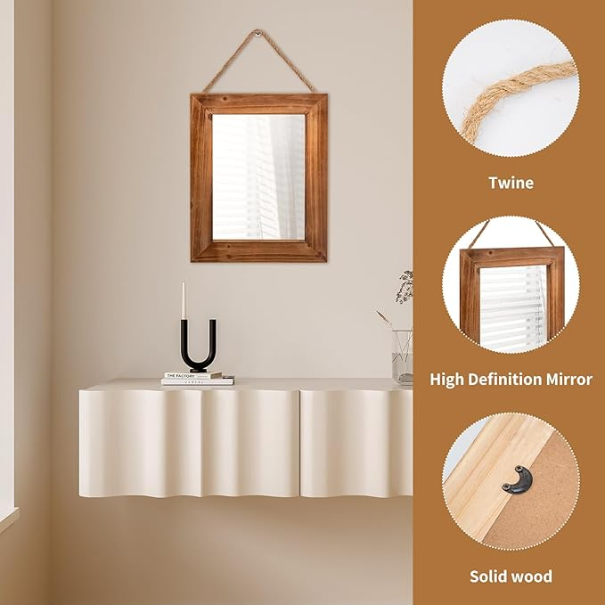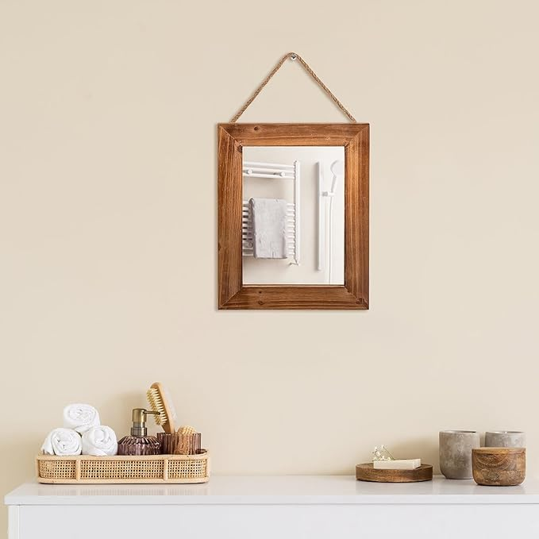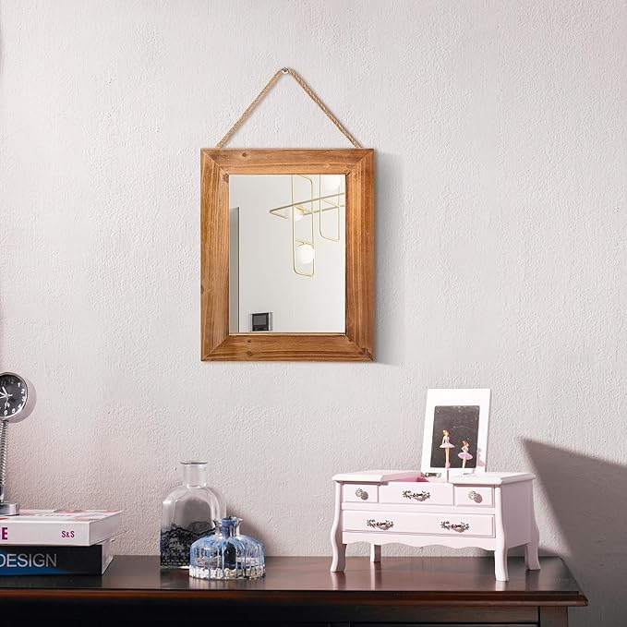

BONNY DODO Wood Mirror 16 X 12 in Farmhouse Solid Rectangle Wall Rustic Wooden Frames Mirrors with Hemp Rope Hanging Decoration for Bedroom, Entryway, Dresser (Wood)

**PRODUCT DESCRIPTION:**

|  |  |
| --- | --- |
| Brand | BONNY DODO |
| Room Type | Bathroom, Living Room, Bedroom |
| Shape | Square |
| Product Dimensions | 15.94"L x 11.81"W |
| Frame Material | Wood |

**About this item**

* Natural Solid Wood Frame & Artisan Craftsmanship：Crafted from premium pine wood, this mirror undergoes 6-step hand-sanding for a silky touch. The thickened frame features distressed antique finishes, showcasing natural wood grains and artificial weathered cracks, giving each mirror a unique rustic character.
* Dual Finish Options：Offers two curated finishes: Natural wood tone showcases Scandinavian simplicity with open-pore waxing, while antique distressed version employs multi-layer glazing to recreate peeling paint and smoke patina, authentically replicating 19th-century farmhouse relics.
* Versatile Space Transformer：16"x12" golden-ratio design optimizes small/medium spaces: Hang at 15° in entryways to enhance depth, mount horizontally on vanities for 180° viewing, or pair with LED string lights to create an Instagrammable backdrop in boutique B&Bs.
* Hemp rope hanging design: This retro style decorative wall mirror combines the functions of decorating walls and practicality. High quality hemp rope is used for hanging and decoration. Please reserve the position of the hemp rope when measuring before purchasing.
* Worry free after-sales service: If you have any questions, you can contact us and we will definitely provide you with satisfactory service